

**Psychosexual Counselling Referral Form**

This form is for professionals to refer people into our service.

Please complete all fields and return this form via secure email to [cwac.shreferrals@hcrgcaregroup.com](mailto:cwac.shreferrals@hcrgcaregroup.com)

**If you do not have an nhs.net or gov.uk email address, you MUST enter [SECURE] in the subject header of the email.**

If you would like to speak to a member of the team regarding your referral, please contact 0300 247 0020.

Patient details

|  |  |  |  |
| --- | --- | --- | --- |
| First name |  | Last name |  |
| Gender |  | DOB |  |
| Country of birth |  | Ethnicity |  |
| Address |  | GP Name & Practice |  |
| Contact number |  |  |
| Interpreter (State Language) |  |  |  |

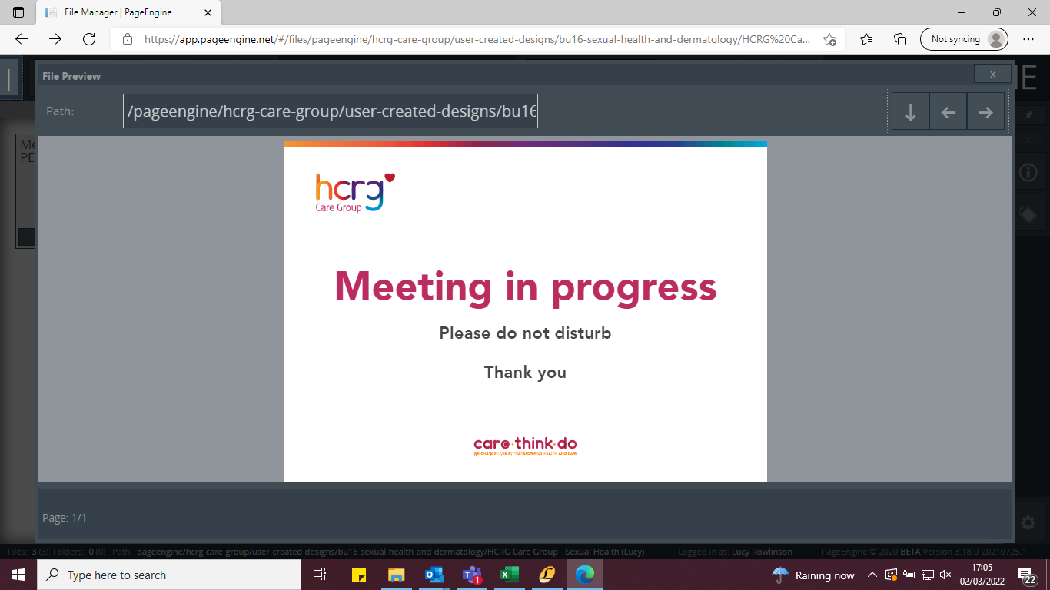

Referral Details

|  |  |
| --- | --- |
| Reason for referral - Include details of the problem / social circumstances |  |

|  |  |
| --- | --- |
| Relevant Medical History – Including details of tests taken and results |  |
| Current Medication |  |



Vulnerabilities

Does the person display or discuss any of the following vulnerabilities? This may be current or historic. Please tick if appropriate

|  |  |  |  |  |
| --- | --- | --- | --- | --- |
| Coercion | Historic |  | Current |  |
| Grooming | Perpetrator |  | Victim |  |
| Power imbalance in relationship | Historic |  | Current |  |
| Any type of violence or abuse | Historic |  | Current |  |
| Self-harm | Historic |  | Current |  |
| Being paid for sex | Yes |  | No |  |
| Paying for sex | Yes |  | No |  |
| Exploitation | Perpetrator |  | Victim |  |
| LGBTQIA+ | Yes |  | No |  |



High-risk groups

Do you consider the person to be one or more of the high-risk groups?

|  |  |  |  |  |
| --- | --- | --- | --- | --- |
| Drug and alcohol issues | Yes |  | No |  |
| Mental health | Yes |  | No |  |
| Learning difficulties or disabilities | Yes |  | No |  |
| Refugee/Asylum seeker/ Unaccompanied child/ Newly arrived in the UK | Yes |  | No |  |



Referrer information

|  |  |  |  |
| --- | --- | --- | --- |
| Contact name |  | Organisation |  |
| Email address |  | Telephone number |  |
| Date of referral |  |  |

|  |  |  |  |  |
| --- | --- | --- | --- | --- |
| Have you discussed the referral with the person / service user? | Yes |  | No |  |
| Has the person / service user consented to the referral and consents for their details to be held by Sexual Heath Teesside? | Yes |  | No |  |



What’s next?

Please return completed referral forms to*:* [cwac.shreferrals@hcrgcaregroup.com](mailto:cwac.shreferrals@hcrgcaregroup.com)

* Referrals will be assessed and responded to within 5 working days.

* If the patient lives outside of Cheshire West and Chester funding will need to be obtained from the relevant ICB, please include this information with the referral.

