

**Vulnerable Adult – Outreach Referral Form Contraception including LARC / STI Screening**

Please complete all fields and return this form via secure email to [vcl.orbishyp@nhs.net](mailto:vcl.orbishyp@nhs.net).

**If you do not have an nhs.net or gov.uk email address, you MUST enter [SECURE] in the subject header of the email.**

If you would like to speak to a member of the team regarding your referral, please contact 01706 202 444. If we are unavailable to take your call, please leave a voicemail, with your contact details, and we will get back to you.

Is the patient aware of the referral being made? (please highlight)

* Yes
* No

Patient details

|  |  |  |  |  |
| --- | --- | --- | --- | --- |
| First name |  | | Last name |  |
| Gender |  | | DOB |  |
| Country of birth |  | | Ethnicity |  |
| Address |  | |  |
| Patients contact number |  | |  |
|  |  |
|  |  |

|  |  |  |  |  |  |  |
| --- | --- | --- | --- | --- | --- | --- |
|  |  |  | |  | | |
| Do we have permission to write to the patient’s home address? | Yes |  | No | |  | Only in an emergency | |  |
| Do we have permission to contact the patient via the contact telephone number? | Yes |  | No | |  | Only in an emergency | |  |

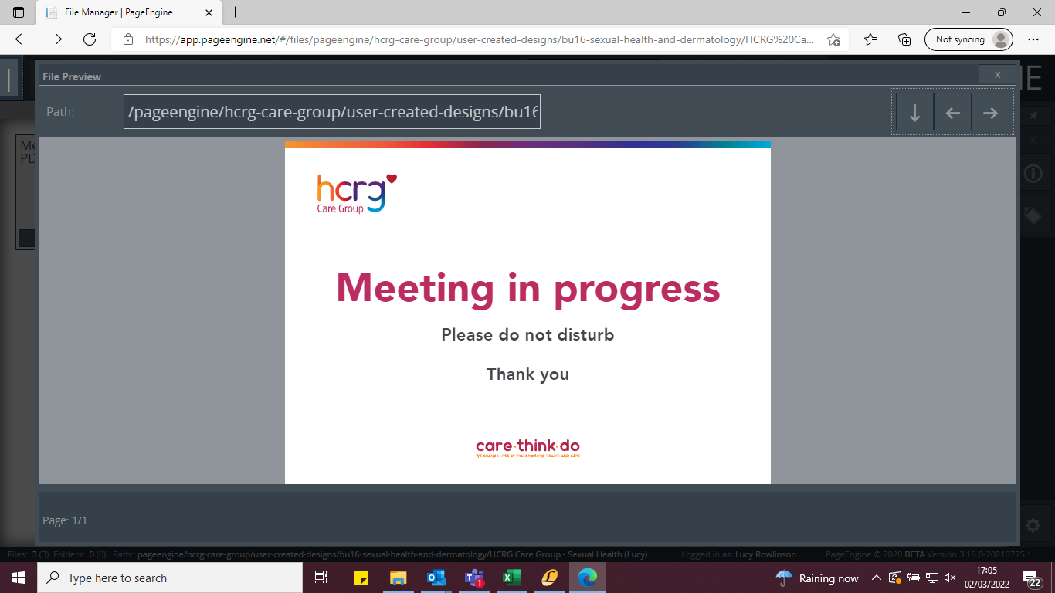

Involvement from social care

|  |  |  |  |  |
| --- | --- | --- | --- | --- |
| Is the Patient known to social care? | Yes |  | No |  |
| Is there an open case with social services? | Yes |  | No |  |

|  |  |
| --- | --- |
| If yes, please provide more information |  |

|  |  |  |  |  |  |
| --- | --- | --- | --- | --- | --- |
| Does the patient have a social worker? | Yes |  | No |  |  |

|  |  |
| --- | --- |
| Name of the designated social worker |  |
| Contact Number (if known) |  |



Referral information

|  |  |  |  |  |  |
| --- | --- | --- | --- | --- | --- |
| Does the patient have any significant issues? | Yes |  | No | |  |
|  |  |  | |
|  |  |  | |

If yes, please provide more information *below:*

|  |  |
| --- | --- |
|  |  |

|  |  |  |
| --- | --- | --- |
|  |  |  |

Reason for referral:

|  |  |
| --- | --- |
|  |  |



Referrer information

|  |  |  |  |
| --- | --- | --- | --- |
| Contact name |  | Organisation |  |
| Email address |  | Telephone number |  |
| Date of referral |  |  |

|  |  |  |
| --- | --- | --- |
|  |  |  |
|  |  |  |
|  |  |  |

What’s next?

Please return completed referral forms to*:* [vcl.orbishyp@nhs.net](mailto:vcl.orbishyp@nhs.net) with the email **SECURE** in the subject header.

* Referrals will be assessed and responded to within 7 working days. You will be notified if the patient does not meet the criteria for the outreach team and additional advice may be given on where best to refer them next.
* Please note incomplete forms will be returned to the referrer for further details.

